Python Programming Lab Task Sets

Set 5
- Q1. Generate Python code for the Fibonacci sequence with Cursor AI. Refine your prompts to handle only positive integers and record the changes and outcomes.
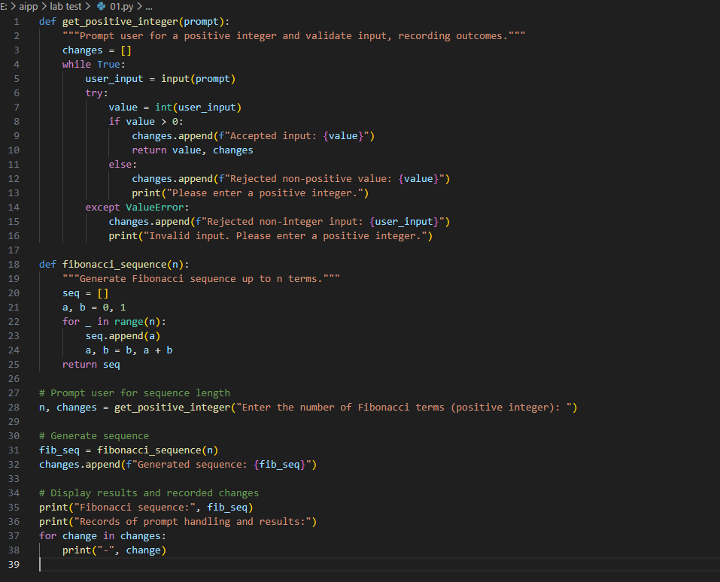
(Each question carries 5 marks)
- Q2. Write a Python queue class (`enqueue`, `dequeue`, `peek`). Use an AI assistant and test the class with multiple scenarios. Describe how AI-generated code manages edge cases and how you improved it.
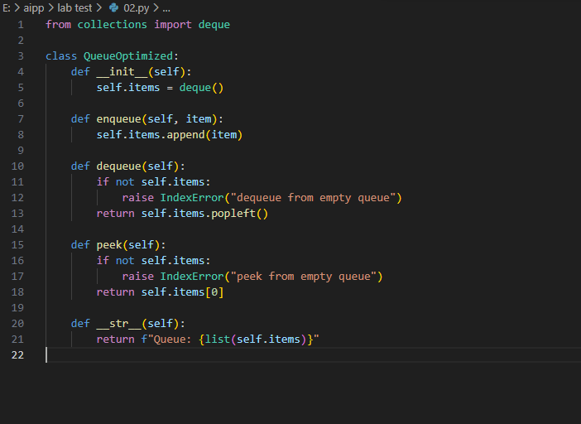
(Each question carries 5 marks)

